Adjacency matrix
Connected graph

9  0 0 0 0 1 1 1 0 1  0 0 0 0 0 0 1 0 1  0 0 0 0 0 0 0 1 0  0 0 0 0 0 0 0 1 0  1 0 0 0 0 1 0 0 1  1 0 0 0 1 0 0 0 1  1 1 0 0 0 0 0 0 0  0 0 1 1 0 0 0 0 0  1 0 0 0 1 1 0 0 0 | 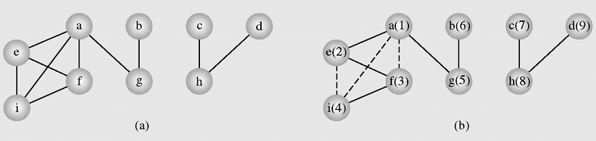

9
0 0 0 0 1 1 1 0 1
0 0 0 0 0 0 1 0 1
0 0 0 0 0 0 0 1 0
0 0 0 0 0 0 0 1 0
1 0 0 0 0 1 0 0 1
1 0 0 0 1 0 0 0 1
1 1 0 0 0 0 0 0 0
0 0 1 1 0 0 0 0 0
1 0 0 0 1 1 0 0 0

